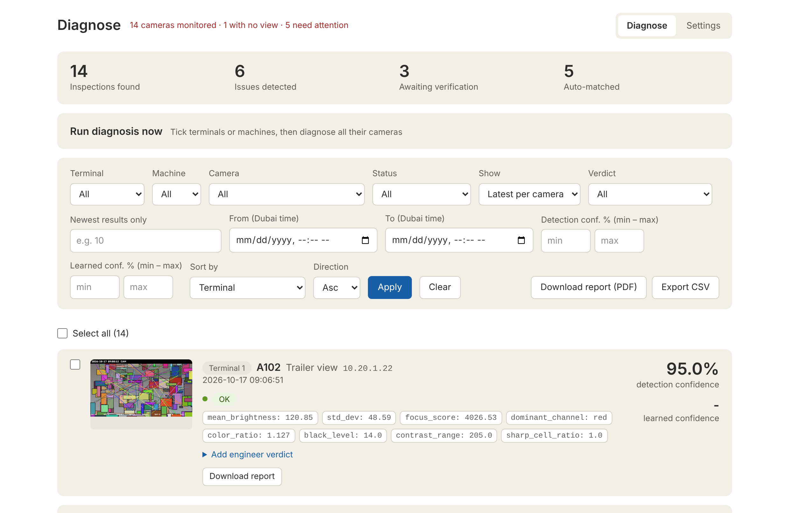

CAMERA HEALTH PLATFORM USER MANUAL

USER MANUAL | VERSION 1.1
OCTOBER 2026

TABLE OF CONTENTS

INTRODUCTION 3
GETTING STARTED 5
DAILY ROUTINE 8
THE CAMERA LIST 12
ADDING A CAMERA 13
EDITING A CAMERA 14
DELETING CAMERAS 15
IMPORTING CAMERAS FROM EXCEL 16
THE DAILY SCHEDULE 19
THE DIAGNOSE TAB 22
READING AN INSPECTION CARD 23
VERIFYING A RESULT 25
HOW THE PLATFORM LEARNS 27
REPORTS AND EXPORTS 29
DELETING INSPECTIONS 31
TROUBLESHOOTING 33
FREQUENTLY ASKED QUESTIONS 34
APPENDIX: STATUS QUICK REFERENCE 35

INTRODUCTION

ABOUT THIS MANUAL
This manual explains how to use the Camera Health Platform day to day: how to start it, how to read the results, how to verify them, and how to keep the camera list and the daily schedule up to date. It is written for the engineers and supervisors who use the platform, not for developers. Technical details are in the separate Technical & Architecture Guide.
IF YOU ARE... | READ FIRST
A verification engineer (daily user) | Chapter 2 Getting started, Chapter 3 Daily routine, Chapter 6 Verifying results
A supervisor or shift lead | Chapter 3 Daily routine, Chapter 7 Reports and exports
The person who maintains the camera list | Chapter 4 Managing cameras, Chapter 5 Daily schedule
Anyone stuck | Chapter 8 Troubleshooting and FAQ

WHAT THE PLATFORM DOES
The platform checks the health of IP cameras mounted on moving machinery. Once a day it takes one picture from every camera, analyses it automatically and flags problems such as no picture, a dirty lens or a colour tint. An engineer then confirms or corrects each finding. The platform remembers every verdict per camera, so the next time the same camera shows the same condition the result is filled in automatically and only genuinely new or worse problems need a person.
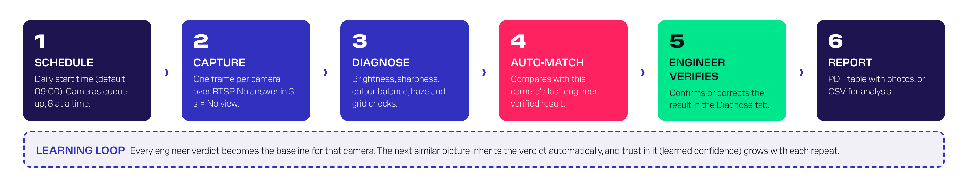
How one camera moves through the platform every day
Everything runs on one computer inside the local network. No internet connection and no cloud service is needed.

WHAT IT CAN DETECT
STATUS | WHAT IT MEANS | COLOUR ON SCREEN
OK | The picture looks normal. | Green
No view | No picture could be read, or the picture is a flat single colour (camera off, cable or network fault, lens fully covered). | Red
Too dark | The picture is almost black (lights off, IR failed, night shot). | Amber
Overexposed | The picture is almost white (sun glare, iris or exposure fault). | Amber
Green / Blue / Red tint | One colour channel clearly dominates (colour fault, IR-cut filter stuck, or a coloured object filling the view). | Amber
Dirty / blurry lens | The picture is soft or milky (dust, salt, condensation, out of focus). | Amber
Partial occlusion | Part of the picture is sharp and part is not (something covering part of the lens). | Amber

Every check except No view can be switched off by the administrator in Settings > Schedule > Detections (Chapter 5). A switched-off problem is no longer reported on new inspections.

KEY TERMS
TERM | MEANING
Inspection | One picture from one camera, with its automatic result. Each camera gets one inspection per daily run.
Detected status | What the computer found in the picture.
Final status | What is reported: the detected status, unless an engineer's verdict corrected it.
Verdict | The engineer's decision on an inspection: Same as detected, or Normal / false detection with a reason.
Auto-matched | The platform copied an earlier engineer verdict for the same camera and the same detection.
Worse than last check | The same problem as an earlier verified one, but clearly more severe, so the old verdict was not copied.
Detection confidence | 50-99.9%. How far the measurement is past its limit. Higher = more obvious. It is not a probability.
Learned confidence | 68-99%. How much the platform trusts an automatic copy. It grows with every repeat of the same result.
Terminal / Machine / Camera | The three names that identify a camera. Together they must be unique.

CAMERA HEALTH PLATFORM

2
GETTING
STARTED

GETTING STARTED

STARTING THE PLATFORM
The platform runs on one dedicated computer (the platform PC). It must be running for the daily inspection to happen.
- On the platform PC, open the platform folder.
- Double-click run.bat (Windows). On a Mac use run.command; on any computer you can also run run.py.
- A black console window opens. The first start may install missing components automatically; this needs the internet only once.
- Your browser opens the dashboard at http://127.0.0.1:5070.
- Leave the console window open. Closing it stops the platform and the daily run.
IMPORTANT
Do not close the black console window and do not let the platform PC go to sleep before the daily run. If the PC wakes up within 3 hours of the start time the run still starts; after that it is skipped until the next day.
To stop the platform on purpose, click the console window and press Ctrl + C.

OPENING THE DASHBOARD FROM ANOTHER COMPUTER
Any computer on the same network can use the platform in a normal browser. Type the platform PC's address followed by :5070, for example http://10.20.0.15:5070. Ask IT for the platform PC's address if you do not know it. Several people can use the dashboard at the same time.

THE SCREEN AT A GLANCE
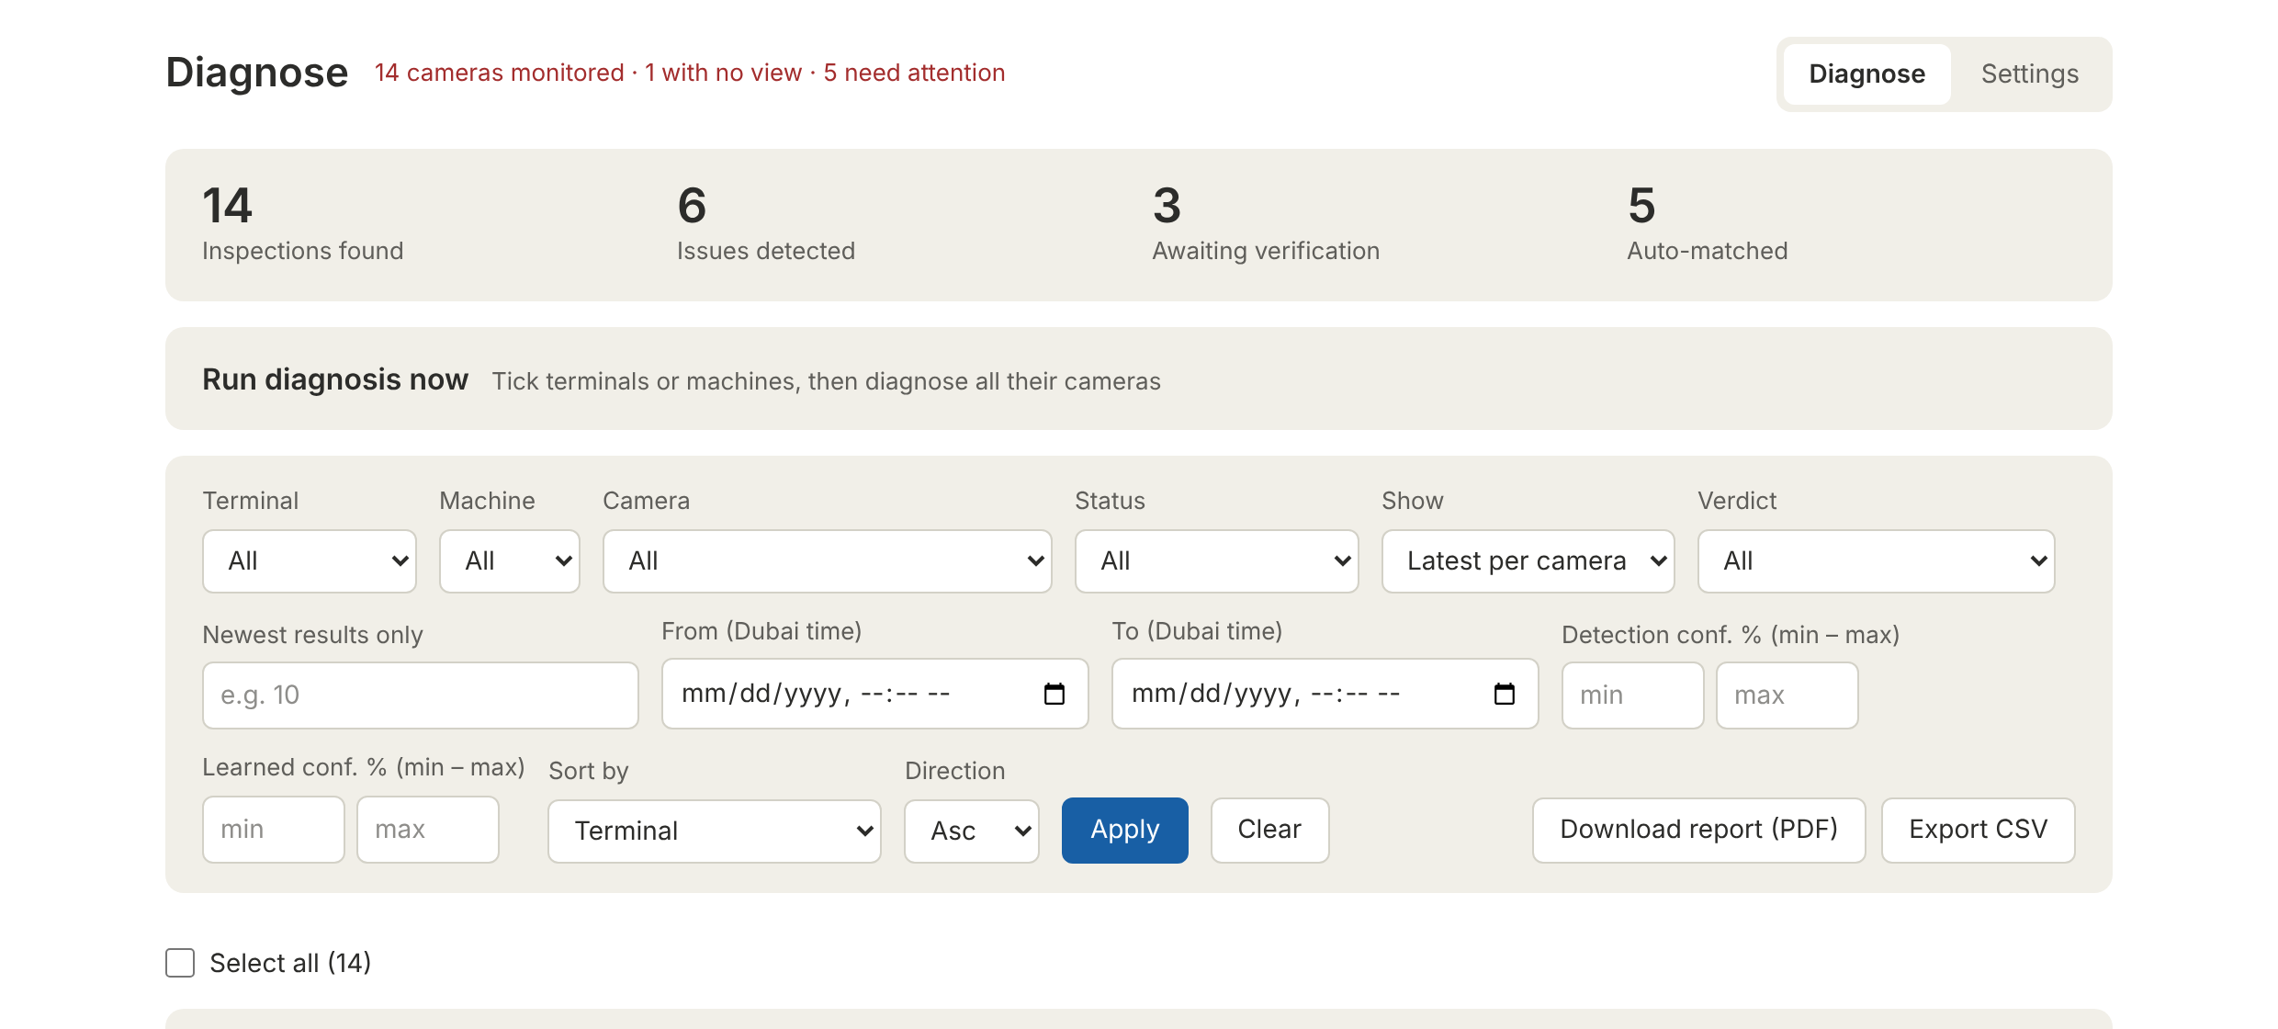
Header, summary figures, Run diagnosis now and the filter bar
AREA | WHAT IT SHOWS
Page title and live status | e.g. "14 cameras monitored · 1 with no view · 5 need attention". Refreshes every 30 seconds. It turns red when a camera has no view or the platform cannot be reached ("Server unreachable").
Diagnose / Settings tabs | Top right. Diagnose is where results are reviewed; Settings is where cameras and the schedule are managed.
Summary figures | Totals for everything that matches the current filters, not only the cards on screen.
Run diagnosis now | Click to open. Starts an extra inspection for chosen terminals or machines.
Filter bar | Narrows the list and is also used for the PDF report and CSV export.

ALL TIMES ARE DUBAI TIME
Times on screen, in reports, in the CSV and in the date filters are Dubai time (UTC+4). The schedule start time uses the platform PC's own clock.

CAMERA HEALTH PLATFORM

3
DAILY
ROUTINE

DAILY ROUTINE
This is the standard operating procedure for the verification engineer on duty. Following it every day keeps the "Awaiting verification" count at zero and makes the learning work for you.
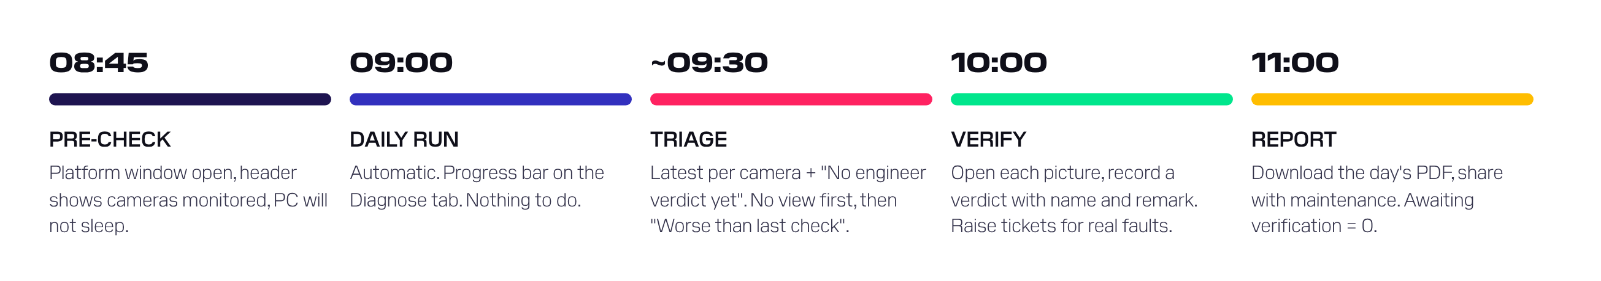
A typical day (times assume the default 09:00 start)

BEFORE THE RUN (ABOUT 08:45)
- Check that the platform console window is open on the platform PC.
- Open the dashboard. The header should read "N cameras monitored" in grey. If it says "Server unreachable", start the platform (Chapter 2).
- In Settings > Schedule, check that Next run shows today at the expected time.

DURING THE RUN (FROM 09:00)
Nothing needs to be done. On the Diagnose tab a progress card shows "done / total cameras diagnosed" and which cameras are being captured. The run normally finishes within half an hour for a few thousand cameras. When it finishes, press Show new results.

TRIAGE (AFTER THE RUN)
- On the Diagnose tab set Show = Latest per camera and Verdict = No engineer verdict yet, then press Apply. This lists every camera whose newest result is a problem that nobody has looked at.
- Set Status = No view first. These cameras send no picture at all and usually need the network or maintenance team.
- Then set Verdict = Worse than last check. These are known problems that got clearly worse since an engineer last confirmed them.
- Then clear the Status filter and work through the rest, highest detection confidence first (Sort by = Detection confidence, Desc).

VERIFY EACH FLAGGED CAMERA
- Click the picture to open it full size. Use the arrow keys to move between pictures, Esc to close.
- Decide whether the platform is right (see the decision guide in Chapter 6).
- Open Add engineer verdict, choose the verdict (and a reason if it was a false detection), type your name and a short remark, and press Save.
- For real faults, raise a maintenance ticket and put the ticket number in the remark, e.g. "Lens cleaning - ticket CM-4471".

REPORT AND CLOSE (LATE MORNING)
- Clear the filters, set Show = Latest per camera and press Download report (PDF).
- Share the PDF with maintenance and your supervisor.
- Check that Awaiting verification on the summary card is 0 for today.

DAILY CHECKLIST
# | CHECK | DONE
1 | Platform running before the start time; Next run correct | ☐
2 | Run finished (progress card shows finished, or Last run started = today) | ☐
3 | All No view cameras reviewed and reported to network / maintenance | ☐
4 | All Worse than last check items reviewed | ☐
5 | Awaiting verification = 0 | ☐
6 | Tickets raised for real faults and numbers written in remarks | ☐
7 | Daily PDF report downloaded and shared | ☐

WEEKLY TASKS
- Review a sample of Auto-matched results (Verdict = Auto-matched) to confirm the automatic copies still look right.
- Look for cameras that have been Disabled for a long time and decide whether to re-enable or delete them.
- Ask IT to back up the platform folder (the database file camera_platform.db and the screenshots folder).
- Check free disk space on the platform PC. Each daily run stores roughly 100-150 KB per camera, and old pictures are not deleted automatically.

CAMERA HEALTH PLATFORM

4
MANAGING
CAMERAS

THE CAMERA LIST
Open Settings > Cameras. The list shows 50 cameras per page, sorted by terminal, machine and camera name.
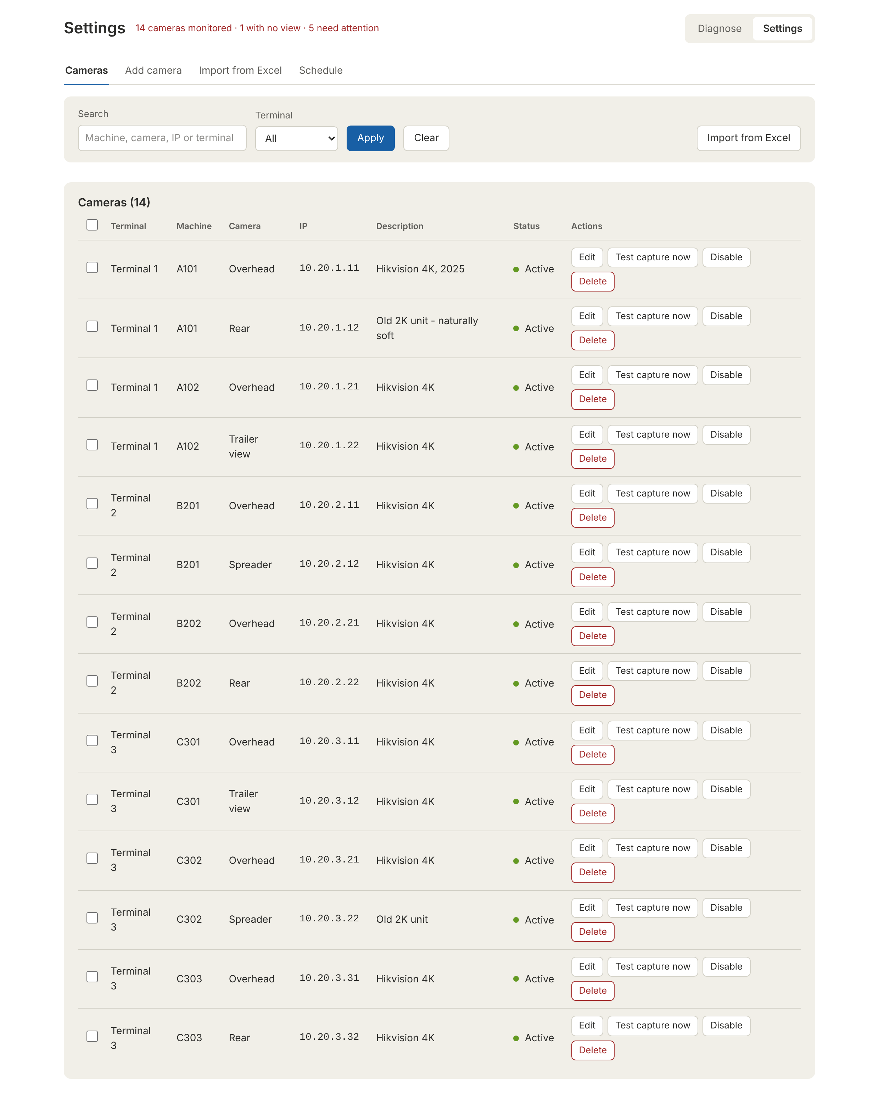
Settings > Cameras
CONTROL | WHAT IT DOES
Search | Finds cameras by machine, camera name, IP or terminal (part of a word is enough).
Terminal | Shows one terminal only. "No terminal" shows cameras without one.
Edit | Opens the camera's details (see Editing a camera).
Test capture now | Takes one picture from this camera immediately and diagnoses it. The result appears on the Diagnose tab.
Disable / Enable | Takes the camera out of (or back into) the daily inspection. Its history is kept. Disabled rows are greyed out.
Delete | Removes the camera from the list and the daily run but keeps all its inspections, verdicts, pictures and reports.

ADDING A CAMERA
Open Settings > Add camera, fill in the form and press Add camera in the bar at the bottom. The camera is included in the next daily run automatically.
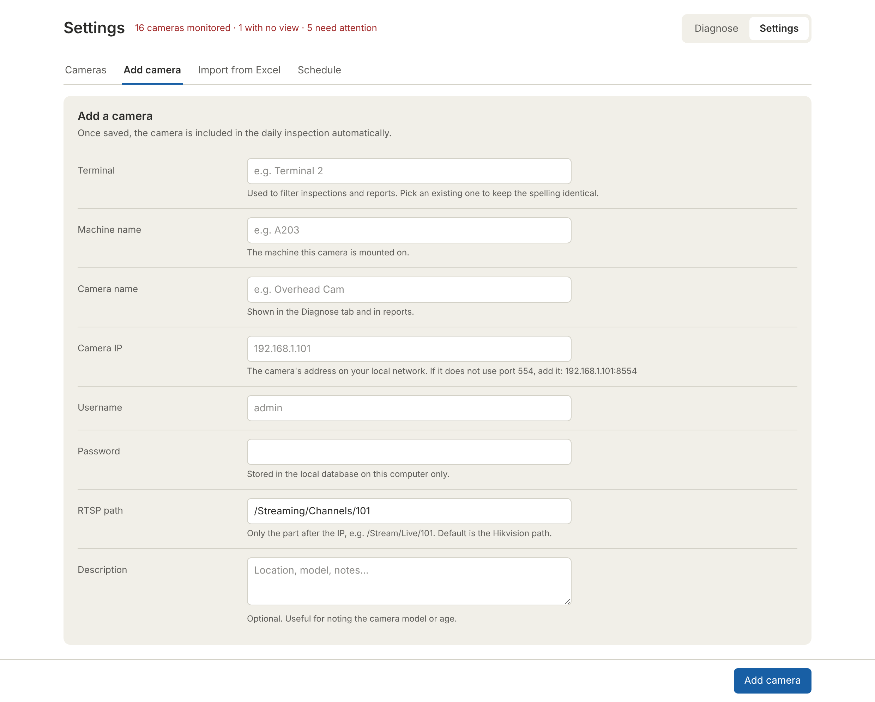
Settings > Add camera
FIELD | REQUIRED | HOW TO FILL IT
Terminal | Yes | e.g. Terminal 2. Pick from the suggestions so the spelling is identical to the other cameras.
Machine name | Yes | The machine the camera is mounted on, e.g. A203. Suggestions appear as you type.
Camera name | Yes | e.g. Overhead, Rear, Spreader. Must be different for each camera on the same machine.
Camera IP | Yes | e.g. 10.20.1.11. If the camera does not use the standard port 554, add it: 10.20.1.11:8554.
Username / Password | Usually | The camera's login. Stored only on the platform PC.
RTSP path | No | Only the part after the IP. Default /Streaming/Channels/101 (Hikvision). Other brands use other paths - ask the camera supplier.
Description | No | Model, age or location notes, e.g. "Old 2K unit". Helpful when verifying.

REPLACING A CAMERA
If you delete a camera and later add (or import) one with exactly the same Terminal, Machine and Camera name, the old history is linked to the new camera automatically. This is useful when a unit is swapped for a new brand or IP.

EDITING A CAMERA
Press Edit in the camera list. Change what is wrong and press Save changes.
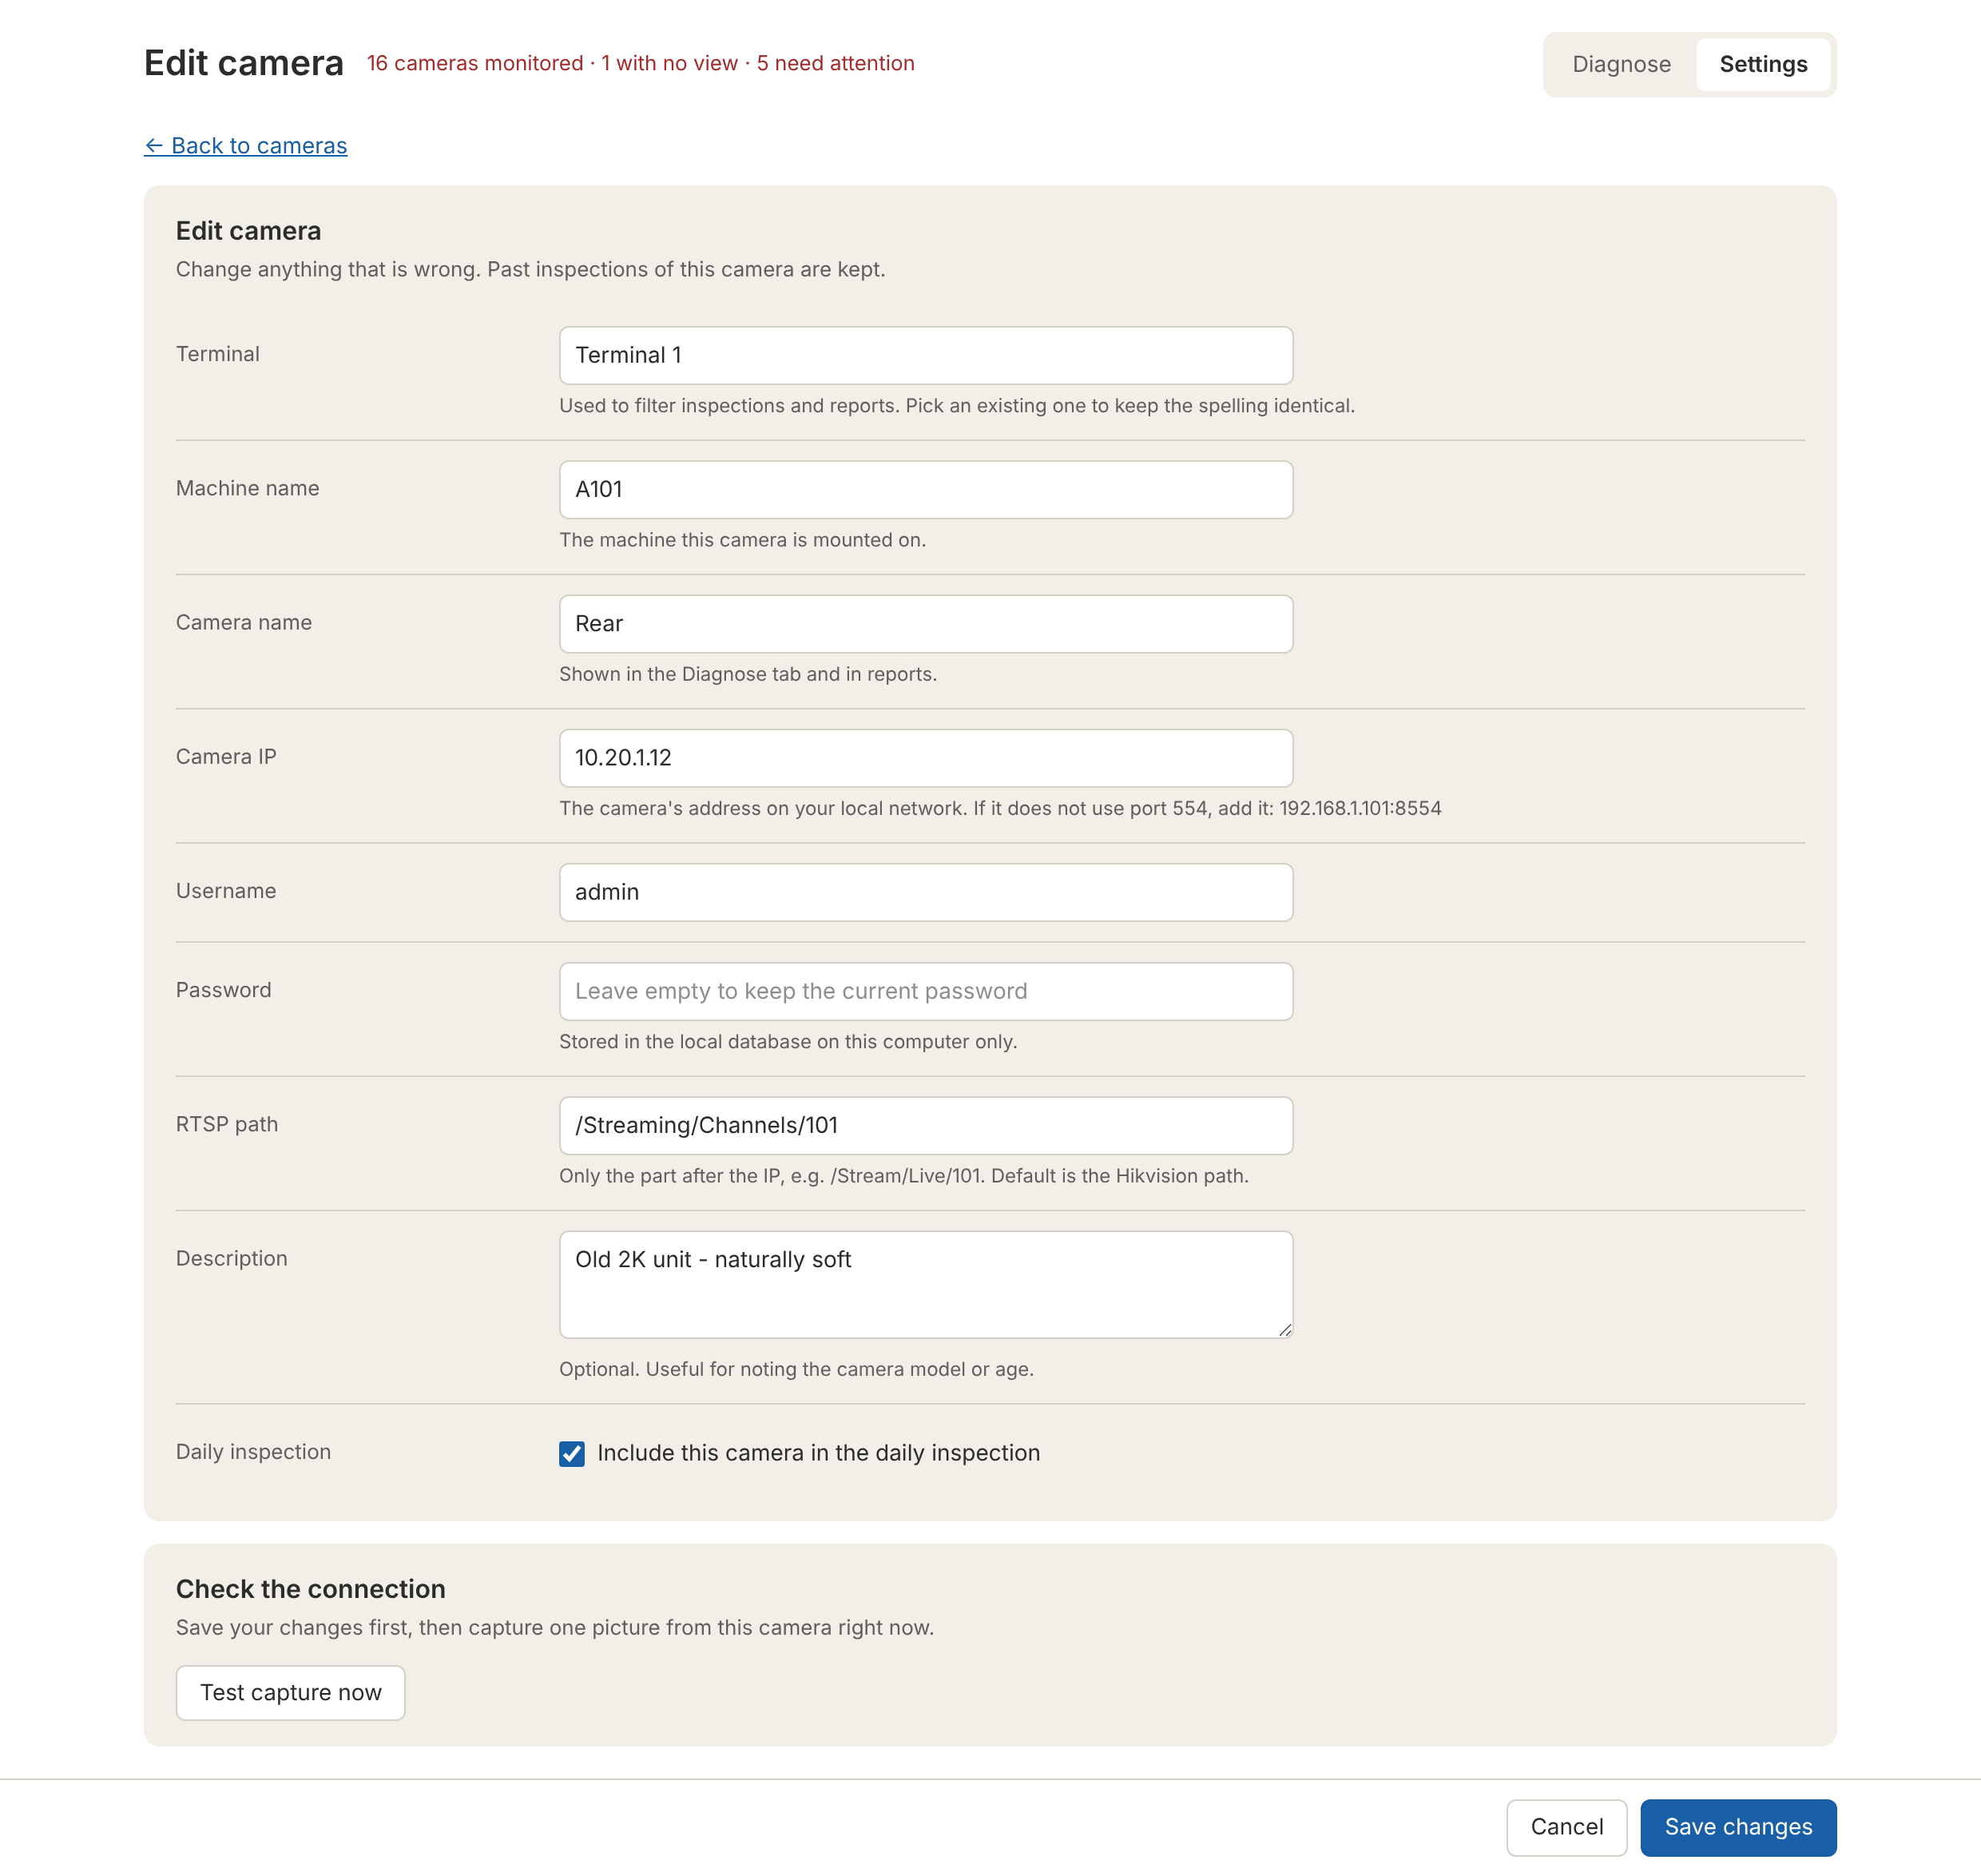
Editing a camera
- Leave Password empty to keep the current password.
- Untick Include this camera in the daily inspection to pause the camera (same as Disable).
- To check the new settings, save first, then press Test capture now in the Check the connection card.
- Past inspections of the camera are always kept.

DELETING CAMERAS
- One camera: press Delete on its row and confirm.
- Several cameras: tick them, then press Delete selected in the blue bar that appears.
- A whole page: tick the box in the table header. To go further, press Select all N cameras to include every page of the current search or terminal filter.
- Deleting more than 10 cameras asks you to type DELETE to confirm.
Deleted cameras disappear from the list and the daily run, but their inspections stay visible on the Diagnose tab and in reports with a grey Removed tag.

IMPORTING CAMERAS FROM EXCEL
Use this to add hundreds or thousands of cameras at once. Open Settings > Import from Excel.
- Click Download the Excel template. It has a Cameras sheet with the right column names and a How to fill sheet.
- Fill in one camera per row. Required columns: Terminal, Machine, Camera, IP. Optional: Username, Password, RTSP path, Description, Active (Yes/No; empty = Yes).
- Save the file as .xlsx (or .csv). Choose it with Choose File.
- Choose what happens to cameras that already exist: Skip it (keep what is saved) or Update it with the values in the file. When updating, empty cells keep the current value.
- Press Import.
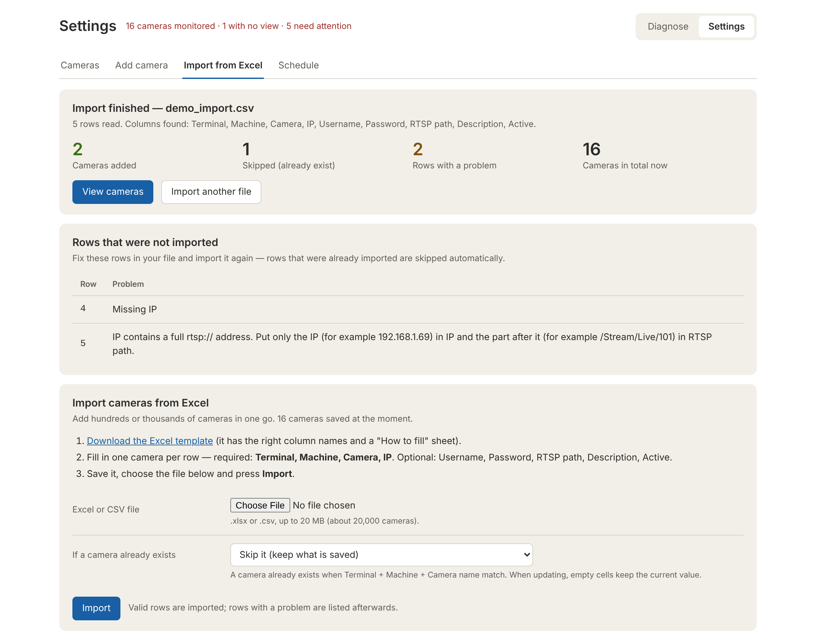
Import result: rows with a problem are listed with their row number
Good rows are always imported, even if other rows have problems. Fix the listed rows in your file and import it again; rows already imported are skipped.
MESSAGE | HOW TO FIX IT
Missing Terminal / Machine / Camera / IP | Fill in the empty required cell.
IP contains a full rtsp:// address | Put only the IP in the IP column and the part after it in RTSP path.
IP '...' contains a space | Remove spaces from the IP.
Active should be Yes or No | Use Yes or No (or leave empty).
Same terminal, machine and camera name as row N | Two rows describe the same camera. Rename or remove one.
Could not find these column headers | Use the template's column names. Header row must be in the first 15 rows.
Old .xls files are not supported | In Excel: File > Save As > Excel Workbook (.xlsx).

GOOD TO KNOW
Column order does not matter and common alternative names are recognised (Machine name, Camera IP, Notes...).
Limit: 20 MB per file, about 20,000 cameras. 2,500 cameras import in about a second.
Keep the Password column formatted as Text so passwords that start with 0 are not changed by Excel.

CAMERA HEALTH PLATFORM

5
DAILY
SCHEDULE

THE DAILY SCHEDULE
Open Settings > Schedule. Changes take effect as soon as you press Save schedule; no restart is needed.
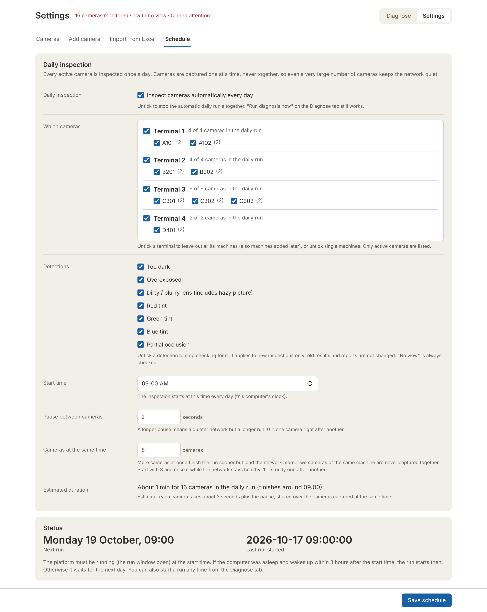
Settings > Schedule
SETTING | DEFAULT | WHAT IT CONTROLS
Daily inspection | On | Untick to stop the automatic daily run altogether. Run diagnosis now still works.
Which cameras | All | Tick boxes per terminal and machine. Unticking a terminal also leaves out machines added to it later. Only active cameras are listed.
Start time | 09:00 | When the run starts every day, by the platform PC's clock.
Pause between cameras | 2 s | 0-600 seconds. A longer pause keeps the network quieter but makes the run longer.
Detections | All on | Which problems are checked. Untick one to stop checking for it on new inspections. No view is always checked. See below.
Cameras at the same time | 8 | 1-32. More finishes sooner but loads the network more. Two cameras on the same machine are never captured together. Raise it step by step while the network stays healthy.
Estimated duration | - | Calculated live: about 3 s per camera plus the pause, shared over the cameras captured at the same time.

CHOOSING WHICH PROBLEMS ARE CHECKED
The Detections list switches individual checks on or off for the whole platform: Too dark, Overexposed, Dirty / blurry lens (including hazy pictures), Red, Green and Blue tint, and Partial occlusion. No view is always checked, because no picture always means no view.
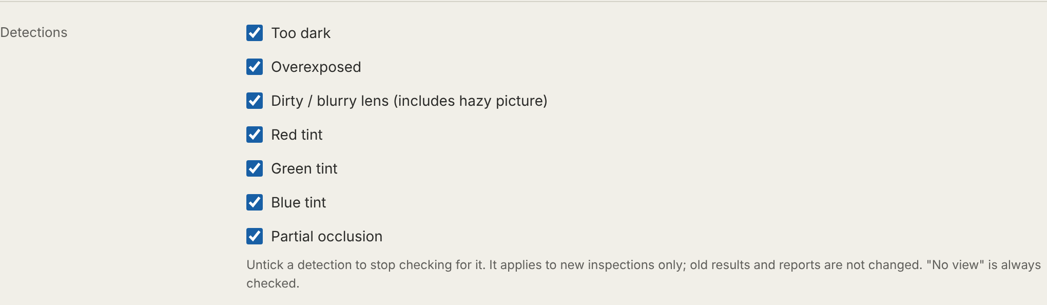
Settings > Schedule > Detections
- The change applies to new inspections only. Earlier results, verdicts and reports stay as they are.
- It applies to all cameras. For a problem that only concerns some cameras (for example an old unit that is always soft), give a verdict instead (Normal / false detection - Old camera); the platform then learns it for that camera only.
- A switched-off check is simply skipped and the picture goes on to the remaining checks, so it can be reported as another problem or as OK. Example: with Dirty / blurry lens off, a hazy picture with a warm colour cast may come out as Red tint.
- Press Save schedule to apply. Record who switched what off and why, and review the list during the quarterly threshold review.
USE SPARINGLY
Switching a detection off means that problem will not be found on any camera. Agree it with the engineering lead first, and switch it back on as soon as the reason has gone.

STATUS CARD
- Next run - when the next automatic run will start.
- Last run started - when the last automatic run began, or "skipped - daily inspection is switched off".
PLANNING GUIDE
About 3,600 cameras take roughly 25 minutes with 8 cameras at the same time, and about 15 minutes with 12-16.
A camera that does not answer within 3 seconds is marked No view immediately, and any camera still not finished after 45 seconds is cut off, so a few broken cameras cannot hold up the run.

CAMERA HEALTH PLATFORM

6
REVIEWING
& VERIFYING

THE DIAGNOSE TAB

SUMMARY FIGURES
FIGURE | MEANING
Inspections found | How many inspections match the filters.
Issues detected | How many of them have a final status other than OK.
Awaiting verification | Problems that have no verdict yet (neither an engineer's nor an automatic one). This is the daily to-do number.
Auto-matched | How many received an engineer's earlier verdict automatically.

FILTERS
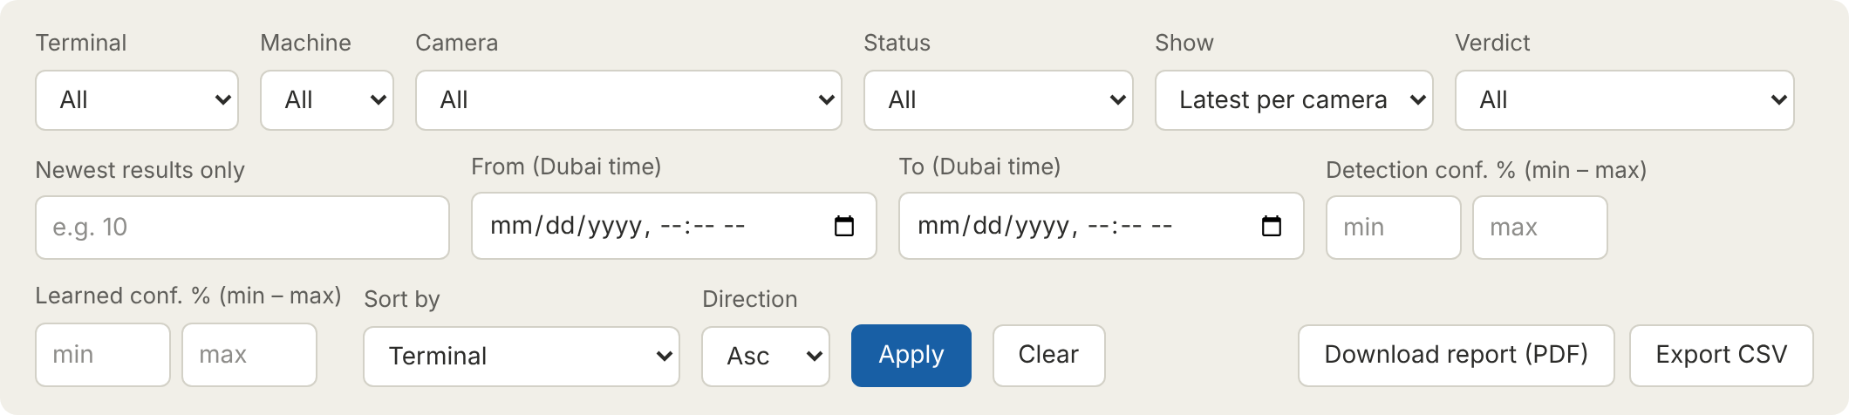
FILTER | USE IT TO...
Terminal / Machine / Camera | Look at one area or one camera. Removed cameras are listed with "(removed)".
Status | Show one final status, e.g. only No view.
Show | All inspections (history) or Latest per camera (today's picture of the fleet).
Verdict | No engineer verdict yet · Verified by an engineer · Auto-matched · Worse than last check.
Newest results only | Limit to the newest N inspections, e.g. 50.
From / To (Dubai time) | A date and time range.
Detection conf. % / Learned conf. % | A minimum and/or maximum, e.g. detection confidence 90-100 for the most obvious problems.
Sort by / Direction | Time, status, detection or learned confidence, terminal, machine or camera; ascending or descending.

Press Apply to filter and Clear to reset. The page shows up to 200 cards; the summary figures, PDF report and CSV always cover everything that matches.

READING AN INSPECTION CARD
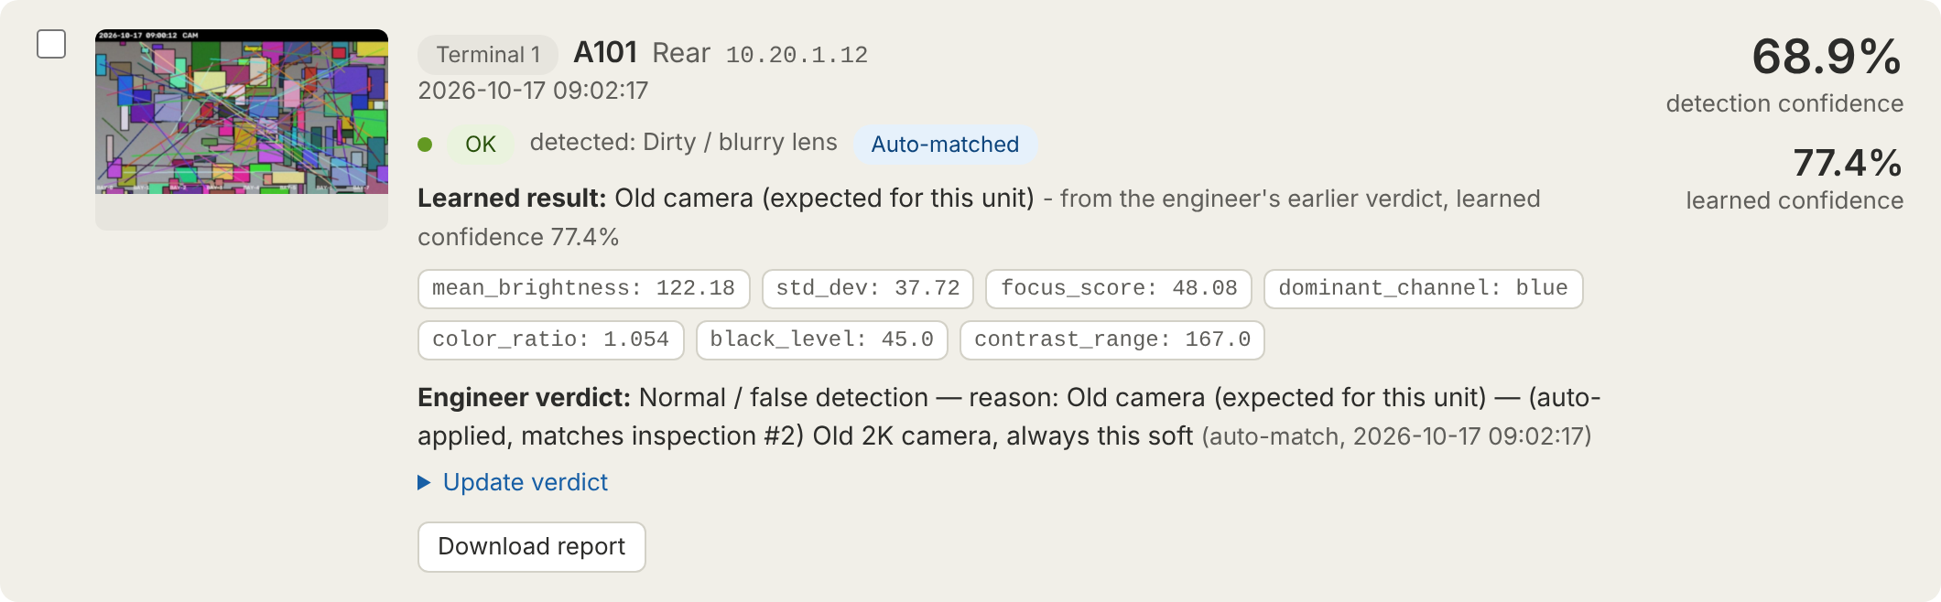
An automatically matched result: detected as Dirty / blurry lens, reported as OK because an engineer marked this unit as an old camera
PART OF THE CARD | MEANING
Picture | Click to enlarge. Arrow keys move to the next or previous picture; Esc closes.
Terminal tag, machine, camera, IP | Which camera. A grey Removed tag means the camera has been deleted from Settings.
Time | When the picture was taken (Dubai time).
Coloured dot and status tag | The final status. Green = OK, red = No view, amber = needs attention.
detected: ... | Shown only when an engineer's verdict changed the result, so you can still see what the computer found.
Auto-matched / Worse than last check | See Chapter 6, How the platform learns.
Learned result | The meaning of the copied verdict and its learned confidence.
Grey measurement chips | The raw measurements (brightness, sharpness, colour ratio...). Useful for comparing two pictures of the same camera.
Engineer verdict | Who decided what, when, with their remark. "auto-match" means it was copied automatically.
Right-hand figures | Detection confidence (top) and learned confidence (bottom, "-" if none).

EXAMPLES
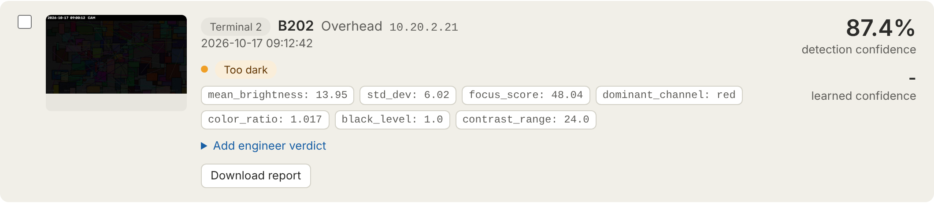
Awaiting verification: Too dark, no verdict yet
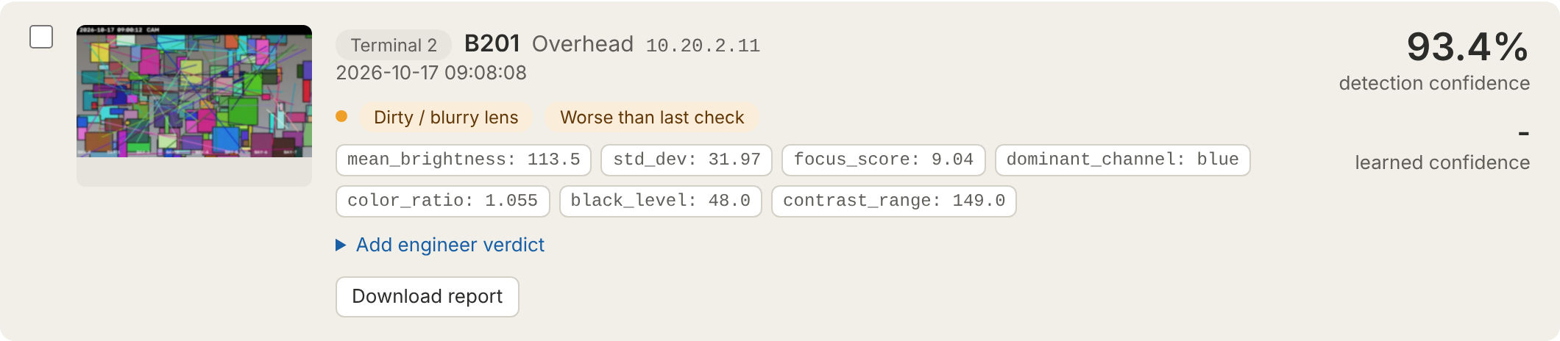
Worse than last check: the lens was confirmed dusty two days ago and is now much worse, so the old verdict was not copied
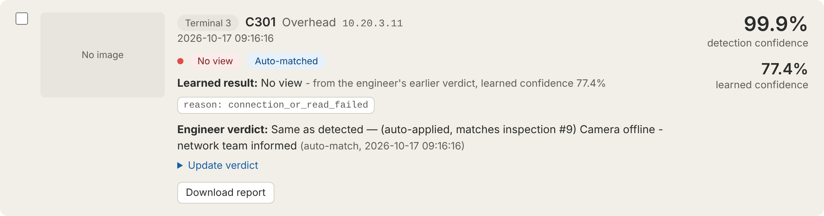
No view: the camera did not answer, so there is no picture

VERIFYING A RESULT
Open Add engineer verdict (or Update verdict) on the card.
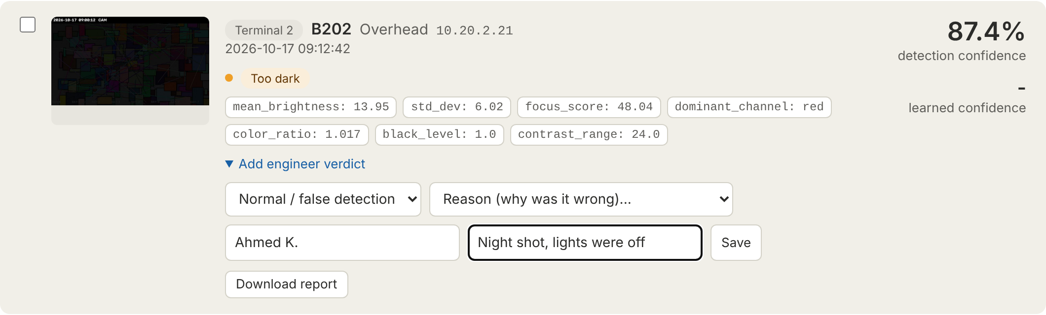
Recording a false detection: a second list asks why
- Choose the verdict: Same as detected (the platform is right) or Normal / false detection (the platform is wrong).
- For a false detection, choose the reason from the second list (see below).
- Type your name and a short remark (what you saw, ticket number).
- Press Save. The card updates in place; the page does not reload.

CHOOSING THE REASON FOR A FALSE DETECTION
REASON | CHOOSE IT WHEN... | REPORTED AS
Old camera (expected for this unit) | The camera always looks like this because of its age or model, e.g. an old 2K unit that is naturally soft. | OK
OK - nothing wrong, the scene caused it | The picture is fine but the scene fooled the check, e.g. a red container filling the view, night time, a plain wall. | OK
A real problem (Dirty / blurry lens, tints, Partial occlusion, ...) | There is a problem, but a different one from what was detected, e.g. detected Too dark but actually something blocks the lens. | That problem

DECISION GUIDE
WHAT YOU SEE IN THE PICTURE | VERDICT TO GIVE
The problem is really there | Same as detected - and raise a ticket
Nothing wrong; the camera is just an older or lower-quality model | Normal / false detection - Old camera
Nothing wrong; a coloured object, darkness, sun or an empty scene caused it | Normal / false detection - OK
A different real problem | Normal / false detection - that problem
Not sure | Do not guess. Use Test capture now in Settings for a fresh picture, or check on site

YOUR VERDICT TEACHES THE PLATFORM
Every verdict you save becomes the reference (baseline) for that camera and that detection. A careless "Same as detected" or "OK" is copied to future pictures, so take a moment to get it right. You can change a verdict at any time with Update verdict; the newest verdict counts.

HOW THE PLATFORM LEARNS
Different camera models give different pictures, so one fixed limit for the whole fleet would cause false alarms. Instead, the platform learns per camera from engineers' verdicts.
- A new picture is analysed. If it is OK, nothing else happens.
- If it shows a problem, the platform looks for the latest inspection of the same camera with the same detection that an engineer verified. Automatic copies are never used as the reference, so the reference cannot drift.
- If the new picture is the same or better than that reference (its detection confidence is not more than 15 points higher), the engineer's verdict and reason are copied. The card is tagged Auto-matched and the verdict shows the engineer name "auto-match".
- If it is clearly worse, nothing is copied and the card is tagged Worse than last check so that a person looks again.

LEARNED CONFIDENCE
When a verdict is copied, the platform shows how much it trusts that copy. Trust grows every time the same result repeats in a row:
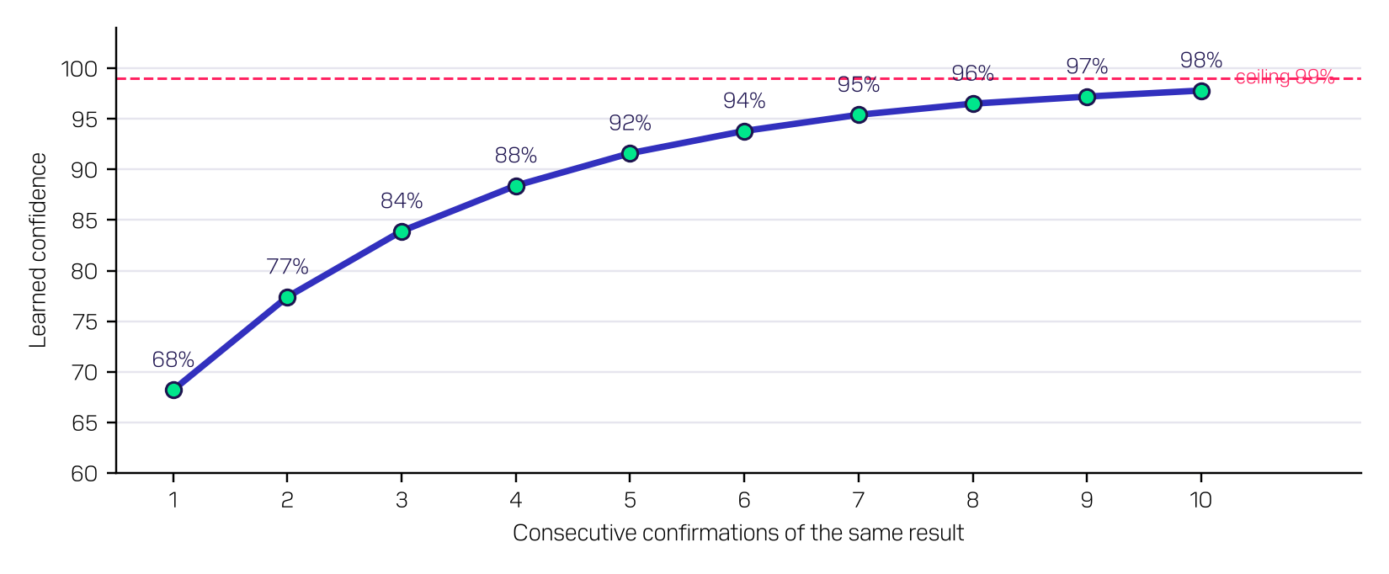
Learned confidence after each consecutive confirmation
Learned confidence measures trust in the copied verdict. It is not a probability that the camera is faulty. A verdict of Normal / false detection with reason OK or Old camera makes the learned result OK, so the picture no longer counts as an issue.

CAMERA HEALTH PLATFORM

7
REPORTS
& EXPORTS

REPORTS AND EXPORTS
YOU WANT... | DO THIS
A report for one inspection | Press Download report on its card.
A report of everything matching the filters | Set the filters, then press Download report (PDF) in the filter bar. Up to 2,000 inspections per report - narrow the filters (one terminal, a date range, Latest per camera) if more match.
A report of hand-picked inspections | Tick the cards (or Select all), then press Download selected as report (PDF) at the bottom of the page.
The data in Excel | Press Export CSV. It contains every inspection matching the filters.

THE PDF REPORT
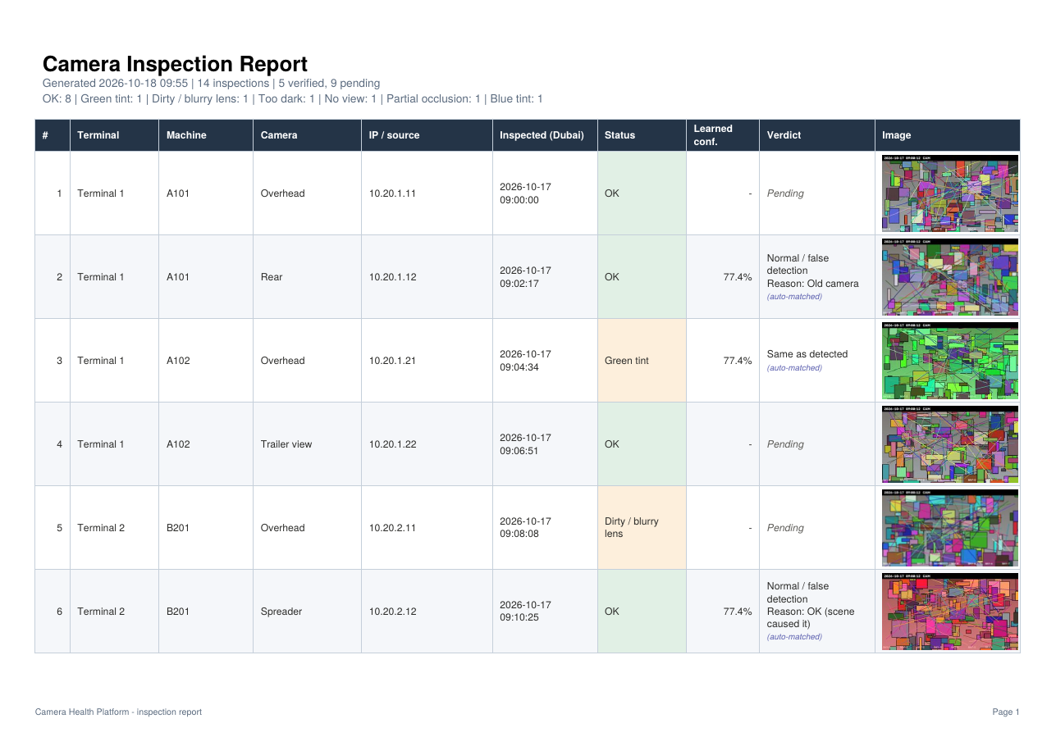
PDF report: one row per inspection, photo in the last column
- Landscape A4, about 6 rows per page, with a summary at the top: when it was generated, how many inspections, how many verified or pending, and a count per status.
- Columns: number, terminal, machine, camera, IP, inspection time (Dubai), final status (coloured), learned confidence, verdict and a small photo.
- Pending means no verdict yet. Small blue text marks auto-matched verdicts; small red text marks worse than last check.
- The company logo appears at the top if one is placed in the platform's static folder (PNG).

THE CSV EXPORT
Columns: Terminal, Machine, Camera, IP, Timestamp (Dubai), Final status, Detected status, Detection confidence, Learned confidence, Learned result, Auto-matched, Worse than last check, Verdict, Reason, Comment, Engineer. Open it in Excel for pivot tables and trends.

DELETING INSPECTIONS
Tick the inspections and press Delete selected at the bottom of the Diagnose page. This removes the inspections, their verdicts and their stored pictures for good. More than 10 at once asks you to type DELETE.
THIS CANNOT BE UNDONE
Deleting an inspection that served as an engineer's reference also removes that reference, so the camera's next matching picture will need a fresh verdict. Normally there is no need to delete inspections; use filters instead.

CAMERA HEALTH PLATFORM

8
TROUBLE-
SHOOTING

TROUBLESHOOTING
PROBLEM | LIKELY CAUSE | WHAT TO DO
One camera is No view | Camera off, cable or switch fault, wrong IP, port, RTSP path or password | Ping the IP. Check the camera's settings in Settings > Edit. Press Test capture now. Different brands use different RTSP paths.
Many cameras at one terminal are No view | Network problem at that terminal | Inform the network team. Re-run that terminal with Run diagnosis now once fixed.
All cameras are No view | The platform PC lost its network connection | Check the platform PC's network cable / Wi-Fi.
No results today | Platform was not running, PC slept more than 3 hours past the start time, daily inspection switched off, or the terminal unticked | Check Settings > Schedule (Daily inspection, Which cameras, Last run started). Start a run with Run diagnosis now.
A camera is missing from the run | It is disabled, deleted, or its machine is unticked in Schedule | Check its row in Settings > Cameras and the Which cameras tree.
Header shows Server unreachable | The platform is stopped or the PC is off | Start it with run.bat on the platform PC.
"N inspections match; one report holds at most 2,000" | Filters too wide | Choose one terminal, a date range, or Latest per camera.
Date filter returns nothing | Dates are in Dubai time | Widen the range; check From is earlier than To.
I gave the wrong verdict | - | Open Update verdict on that card and save the correct one. The newest verdict counts.
A problem type never shows any more | That detection is switched off | Check Settings > Schedule > Detections.
The same false alarm keeps coming back | No verdict yet, or the picture is a bit worse each time | Give a verdict (e.g. Old camera). If it is tagged Worse than last check, verify it again.

FREQUENTLY ASKED QUESTIONS

DOES THE PLATFORM NEED THE INTERNET?
No. It works entirely on the local network. The internet is used only once, when the platform is first installed.

IS THE DETECTION CONFIDENCE A PROBABILITY?
No. It shows how far a measurement is past its limit: around 55-65% means borderline, 95-99% means obvious.

WHY DOES AN OK PICTURE SHOW 95%?
OK is reported with a fixed 95% when no check triggers.

WHY IS A PICTURE DIRTY / BLURRY ALTHOUGH THE LENS LOOKS CLEAN?
Some older or lower-resolution cameras are naturally soft. Mark it Normal / false detection - Old camera once; future similar pictures are then accepted automatically.

DOES THE DATE AND CAMERA-NAME TEXT IN THE PICTURE AFFECT THE RESULT?
No. The strip at the top of the picture where cameras print the date and name is ignored in all measurements.

WILL DELETING A CAMERA LOSE ITS HISTORY?
No. Inspections, verdicts, pictures and reports are kept and marked Removed.

CAN SEVERAL ENGINEERS WORK AT THE SAME TIME?
Yes. Each saves verdicts on different cards; the newest verdict on a card counts.

ARE OLD PICTURES DELETED AUTOMATICALLY?
No. Ask IT to archive the screenshots folder when disk space runs low.

CAN WE STOP THE PLATFORM CHECKING FOR ONE KIND OF PROBLEM?
Yes. An administrator can untick it in Settings > Schedule > Detections. It then applies to all cameras and new inspections only. For one camera, give a verdict instead.

CAN THE PLATFORM CHECK CAMERAS MORE THAN ONCE A DAY?
The automatic run is daily. Use Run diagnosis now or Test capture now for extra checks at any time.

APPENDIX: STATUS QUICK REFERENCE
STATUS | TYPICAL CAUSE | FIRST ACTION
No view | Power, network, IP / port / path / password, camera failed | Ping; Test capture now; ticket to network or maintenance
Too dark | Lights off, IR illuminator failed, night | Check lighting / IR; if expected at that time, verdict OK
Overexposed | Sun glare, iris / exposure setting | Check camera exposure settings; consider position
Green / Blue / Red tint | Colour fault, IR-cut filter stuck, coloured object in view | Compare with earlier pictures; firmware / filter check
Dirty / blurry lens | Dust, salt, condensation, focus, old camera | Lens cleaning; refocus; Old camera if expected
Partial occlusion | Cable, bracket, tarpaulin, mud on part of the lens | Remove obstruction; check mounting

Version number: 1.1
Date: 18 - 10 - 2026
Author/s: Camera Health Platform training team
Changes/Reasons: 1.1 - Detections switches in Settings > Schedule; worse-than-last-check margin 15 points. 1.0 - first issue

PLEASE CONTACT THE

CAMERA HEALTH PLATFORM

TEAM FOR MORE INFORMATION

